UCS 1602 - Compiler Design Assignment – 2 -Lexical Analyser Using Lex Tool

**Swetha Saseendran**

**CSE-C**

**185001183**

**Aim:**

To develop a Lexical analyzer to recognize the patterns namely, identifiers, constants, comments and operators using the following regular expressions and construct symbol table for the identifiers with the following information.

**Code:**

/*lex program for lexical analyzer*/

%{

#include<stdio.h>

#include<string.h>

typedef struct

{

    char var[10];

    char type[10];

    char value[10];

}symbol_table;

symbol_table t[10];

int ind=0;

char type[10];

int insert(char *token)

{

    int i;

    for(i=0;i<=ind;i++)

    {

        if(strcmp(token,t[i].var)==0)

            return 0;

    }

    return 1;

}

%}

keyword int|float|double|char|do|while|for|if|break|continue|void|return|else|string

function main|printf|scanf|getchar|getch

strconst \".*\"

preprocessor #.+

identifier [_a-zA-Z][a-zA-Z0-9]*

numconst [0-9]+|[0-9]+[.][0-9]+

special_char [{}(),;]

sing_comment [//].*

multi_comment "/*"(.|\n)*"*/"

relational "<="|">="|"<"|"=="|">"

arithmetic "+"|"-"|"--"|"++"|"%"|"*"|"/"

assign "="|"+="|"-="|"/="|"%="

logical "||"|"&&"

bitwise "<<"|">>"|"^"|"~"

%%

{keyword} {

    printf("KEYWORD ");

    if(strcmp(yytext,"int")==0)

    {

        strcpy(type,yytext);

    }

    else if(strcmp(yytext,"float")==0)

    {

        strcpy(type,yytext);

    }

    else if(strcmp(yytext,"char")==0)

    {

        strcpy(type,yytext);

    }

    else if(strcmp(yytext,"double")==0)

    {

        strcpy(type,yytext);

    }

}

{function} printf("FUNCTION\t");

{sing_comment} printf("SINGLE-LINED COMMENT\t");

{multi_comment} printf("MULTI-LINED COMMENT\t");

{logical} printf("LOP\t");

{bitwise} printf("BOP\t");

{numconst} {

    printf("NUMCONST ");

    if(strcmp(t[ind].value,"null")==0)

    {

        strcpy(t[ind].value,yytext);

        ind++;

    }

}

{strconst} {printf("STRCONST ");}

{preprocessor} printf("PPDIR\t");

{identifier} {

    printf("ID\t");

    if(insert(yytext))

    {

        strcpy(t[ind].type,type);

        strcpy(t[ind].var,yytext);

        strcpy(t[ind].value,"null");

        ind++;

    }

}

{special_char} printf("SP\t");

{relational} printf("RELOP\t");

{arithmetic} printf("AOP\t");

{assign} {

    printf("ASSIGN ");

    ind--;

    }

%%

int yywrap(void){

    return 1;

}

void main()

{

    yyin=fopen("in.txt","r");

    yylex();

    int i;

    printf("\n\nType\tVariable\tValue\n");

    for(i=0;i<=ind;i++)

    {

        printf("%s\t%s\t%s\n",t[i].type,t[i].var,t[i].value);

    }

}

**INPUT TEXT FILE TO PARSE (in.txt):**

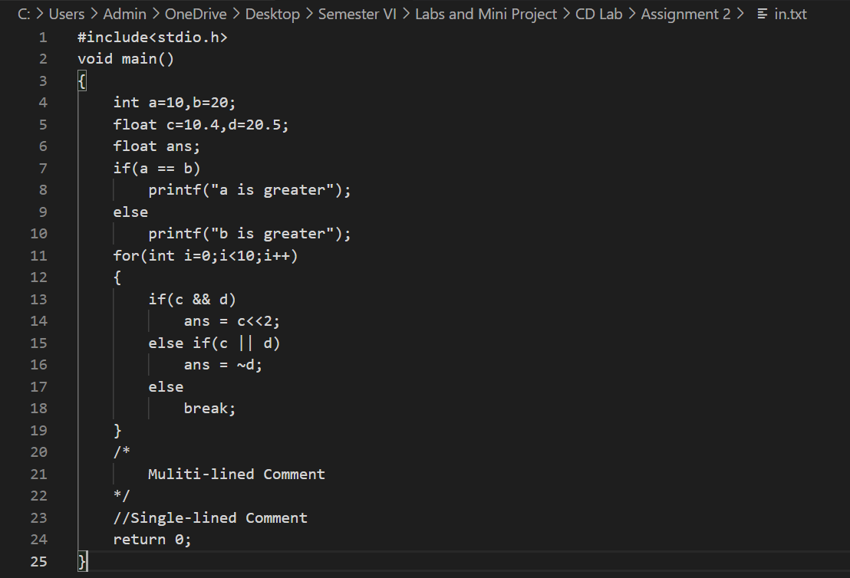

**OUTPUT:**

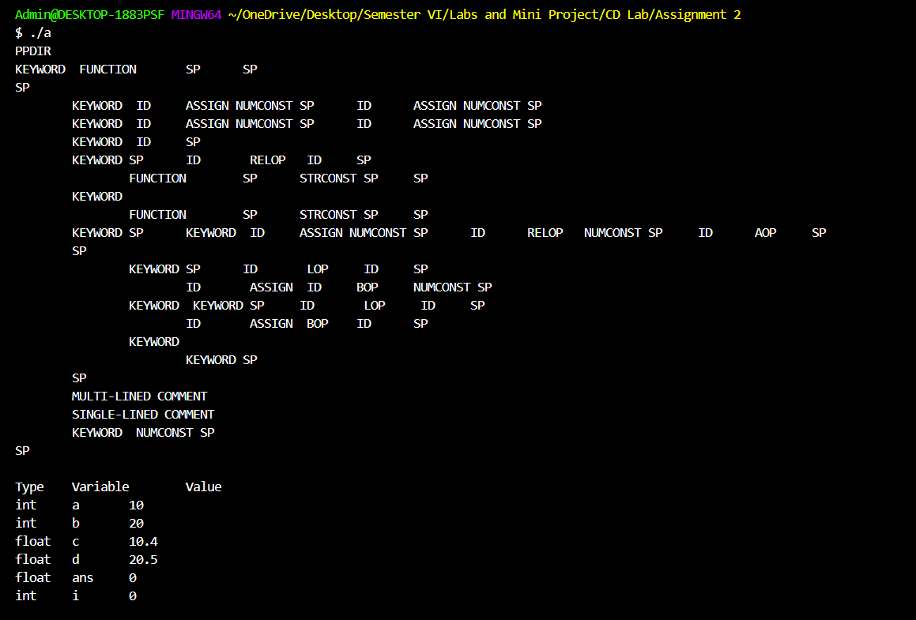

**LEARNING OUTCOME:**

* Understood the basic functionalities and working of a Lexical Analyser, that it breaks the syntaxes into a series of tokens and analyses it.
* Understood the basic working of the lex tool and that its more powerful and convenient to use for Lexical Analysis task compared to conventional C programming.
* Learnt how to implement regular expressions in lex tool and develop parsers to identify tokens and thereby converting regex to finite automata.
* Understood the working of the symbol table and to implement a basic symbol table using Lex on the parsed C program.
* Also got a good visualization behind the process of compilation and role of Lexical Analyser in it. Also, the assignment helped me to understand how an analyser maps various tokens based on given specifications.

**RESULT:**

Successfully implemented the code to stimulate Lexical Analyser to scan the entire source code and identify the tokens and form the symbol table for the same using the lex tool.